**Scenario**

As the IT administrator for a small corporate network, I was asked to modify the power and battery settings for the laptop in the Executive Office. My task was to:

* Set the following default settings for the power button action (for all existing power plans):
  + On battery: **Hibernate**
  + Plugged in: **Shut down**
* Set the computer to use a password on wakeup.
* Select and modify the High Performance power plan as follows:

|  |  |  |
| --- | --- | --- |
| **Option** | **On battery** | **Plugged in** |
| Turn off the display | 5 minutes | 1 hour |
| Put the computer to sleep | 30 minutes | 5 hours |
| When lid is closed | Sleep | Do nothing |

1. Set the following default settings for the power button action.
   1. Right-click **Start** and then select the **Power Options**.
   2. Under *Related settings*, select **Additional power settings**.
   3. From *the Power Options window*, select **Choose what power buttons do** and modify the power button behavior.

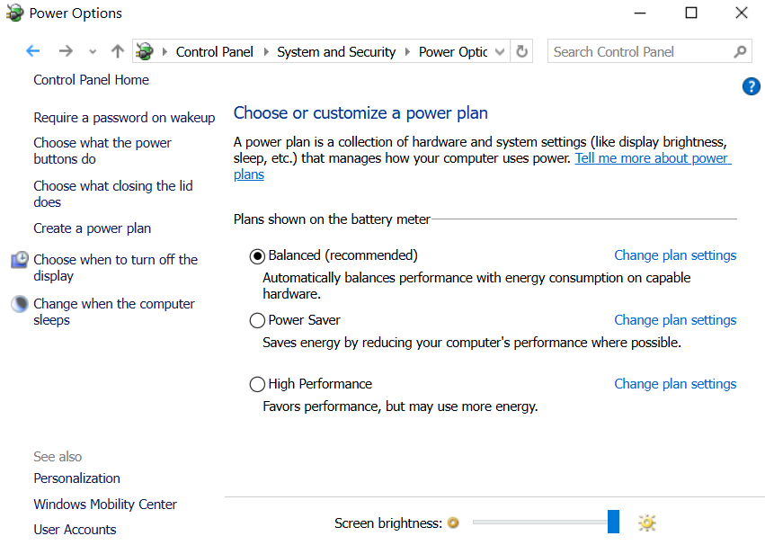

*Ref1: Choose what power button do*

*Ref2: Update the power button settings*

1. Set the computer to use a password on wakeup.
   1. Select **Change settings that are currently unavailable**
   2. *Under Password protection on wakeup*, select **Require a password** and **save changes**.

*Ref3: Password settings*

1. Select and modify the High-Performance power plan as follows.
   1. Under *High additional plans*, select **High Performance.**
   2. Select **Change plan settings** and update changes.
   3. Then for the settings when the lid is closed, select **Change advance Power settings.**
   4. Expand **Power buttons and lid,** expand **lid close action.**
   5. Make the requested changes.
   6. Select **Ok,** Select **Save Changes.**

*Ref4: Select High Performance / Change plan Settings*

*Ref5: Update the changes*

*Ref5: Changes when the lid is closed*

1. Create a custom power plan (if needed)

*Ref6: Create a power plan named “Presentation”*